Preparação DATAGUARD SAP

Instalação dos binários da SAP



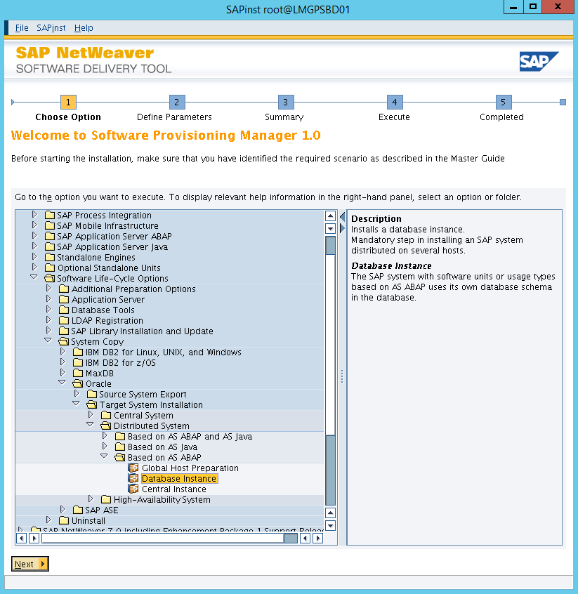

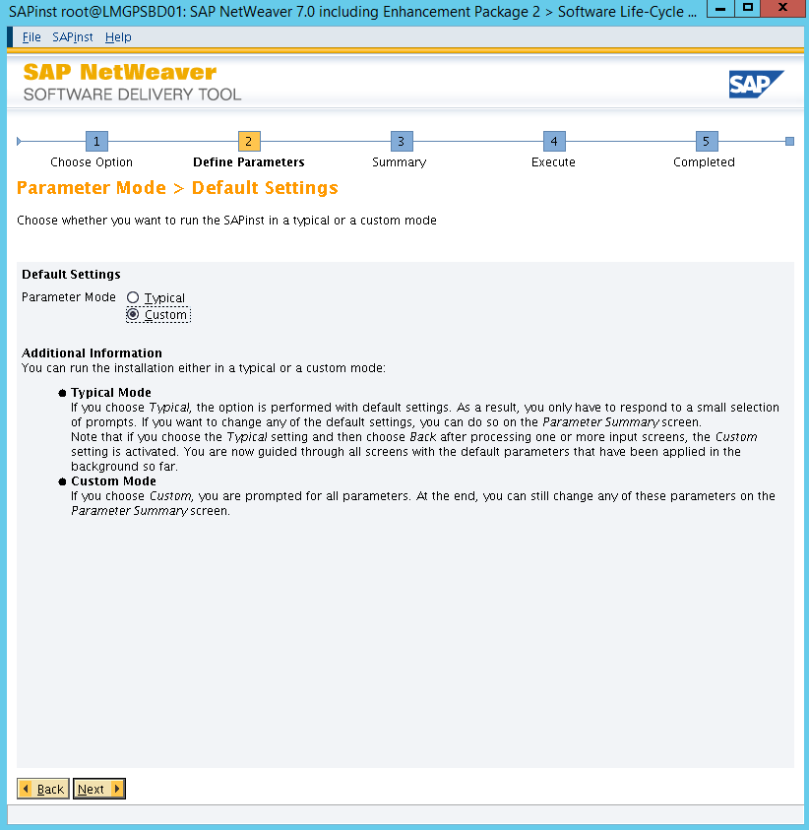

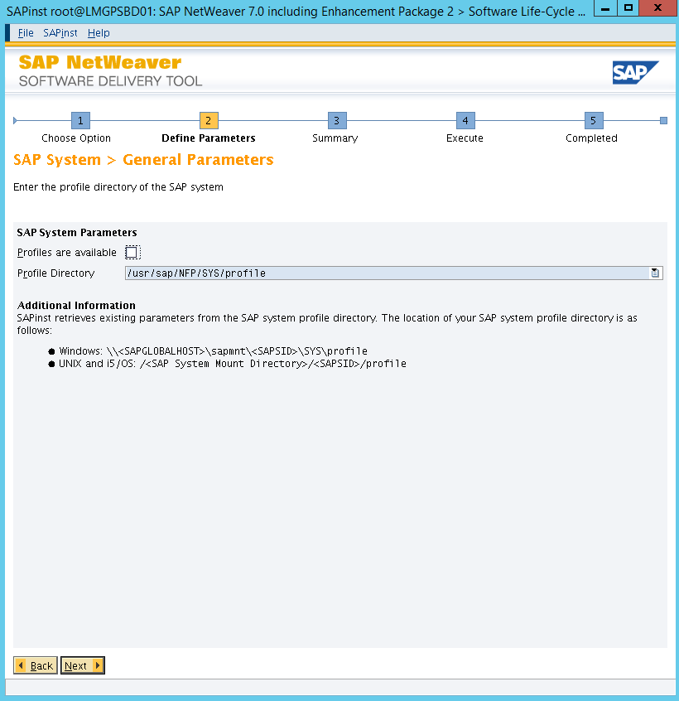

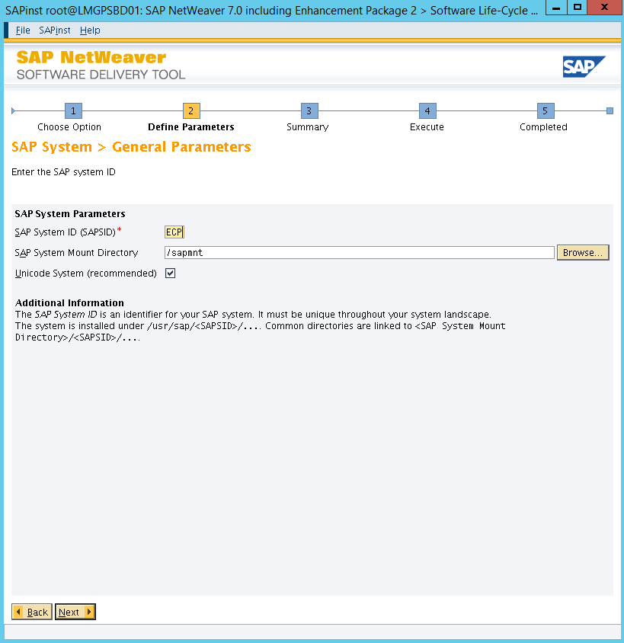

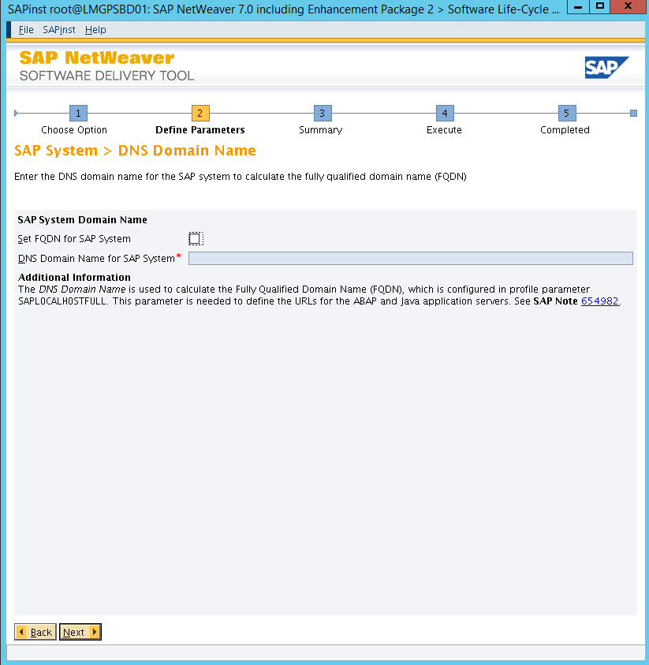

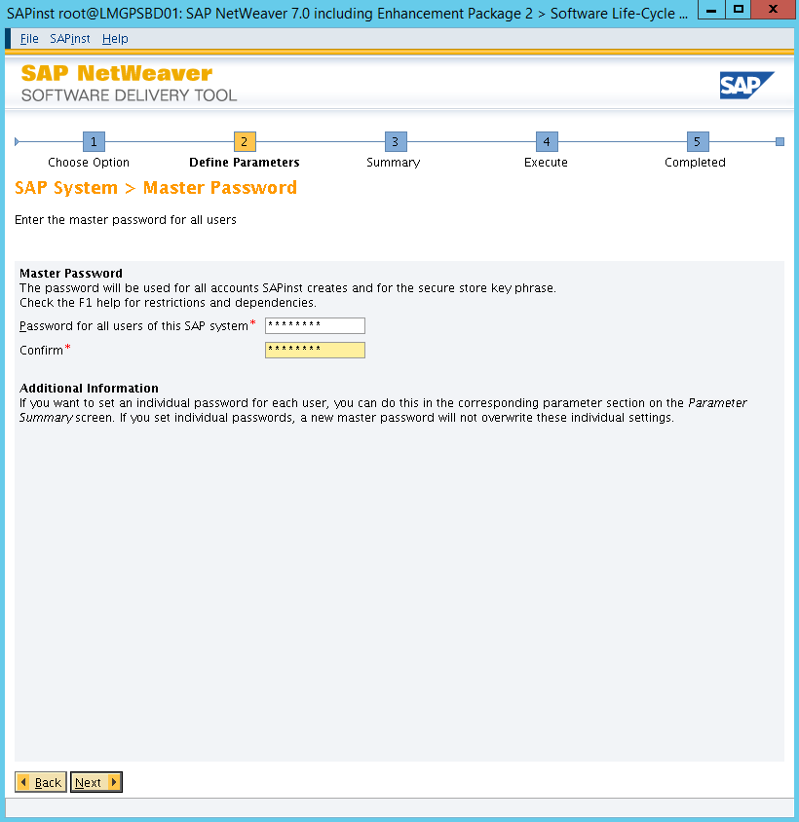

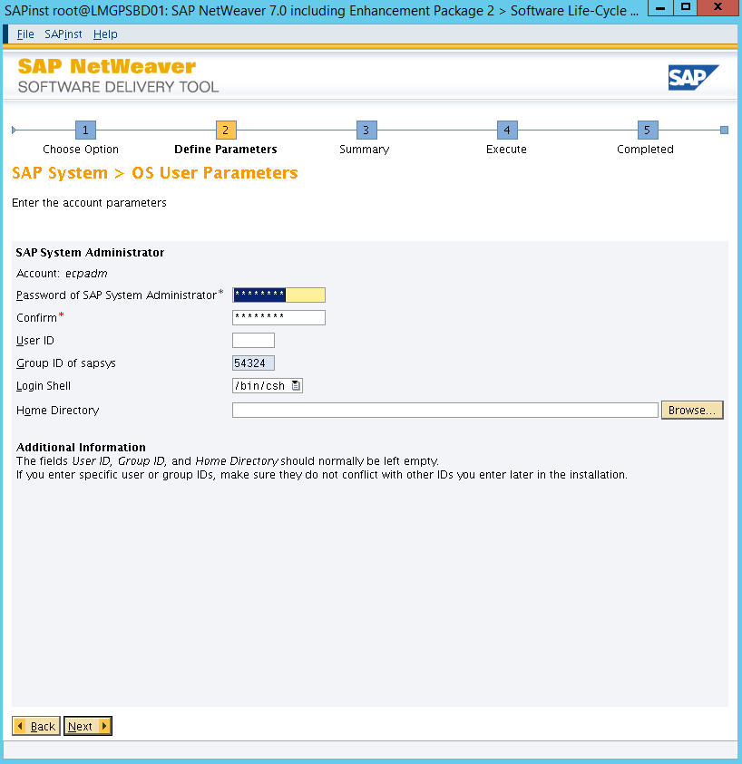

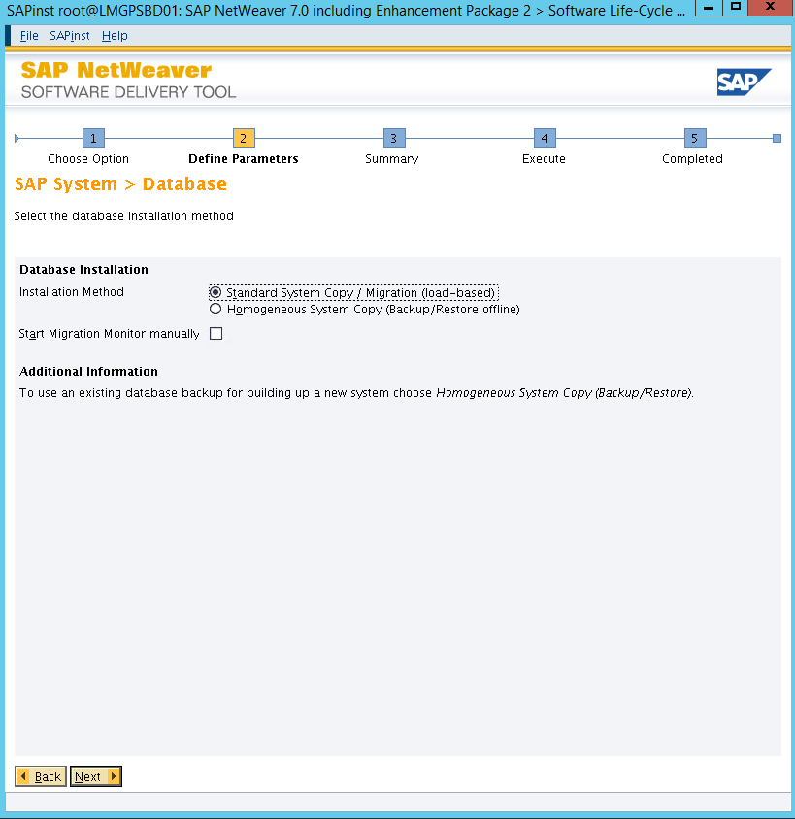

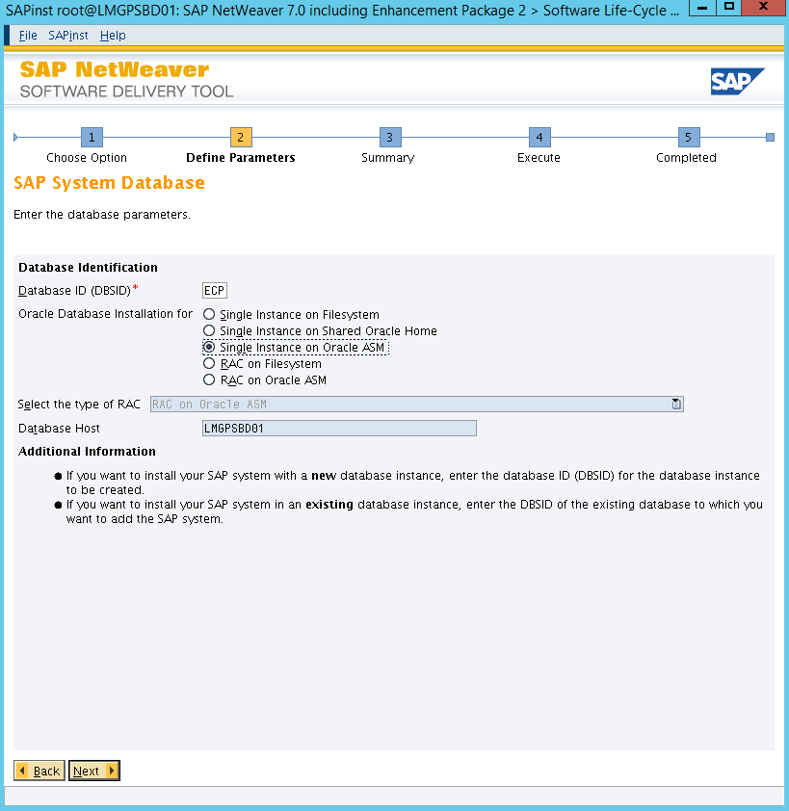

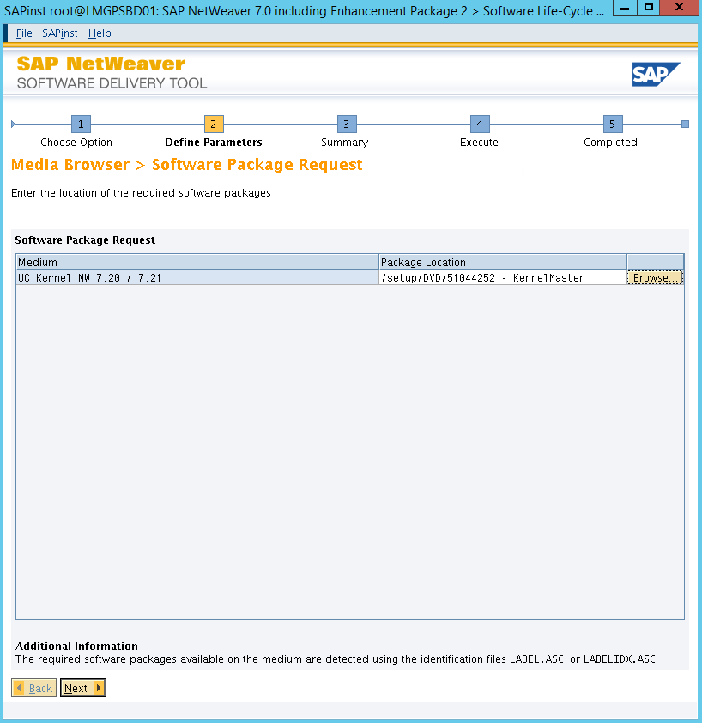

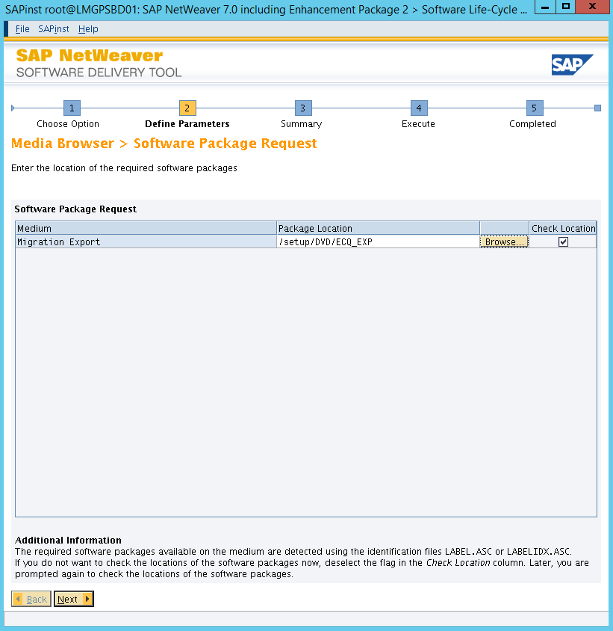

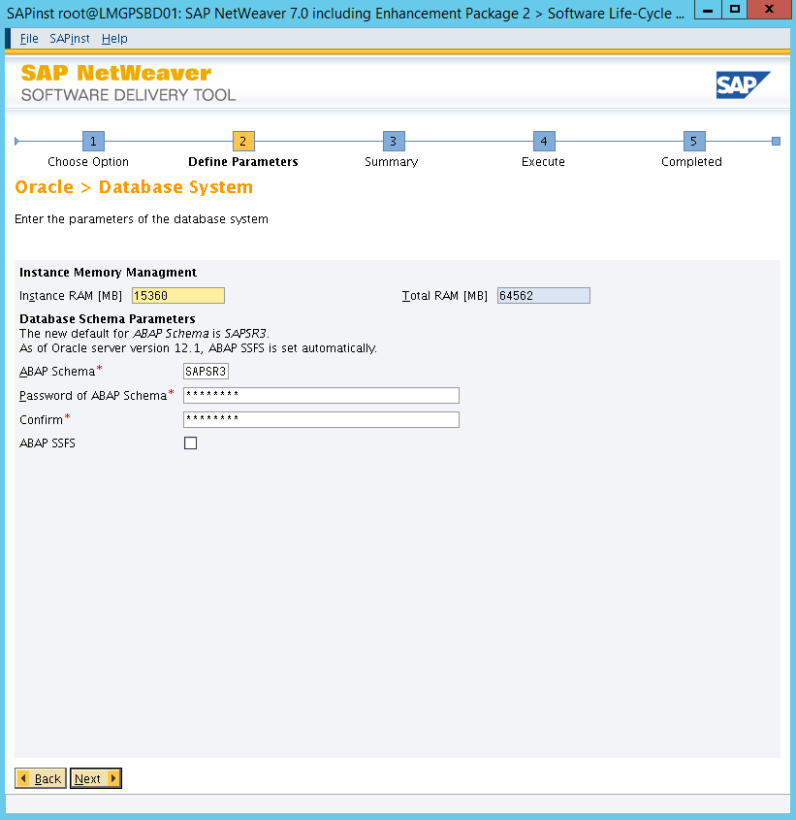

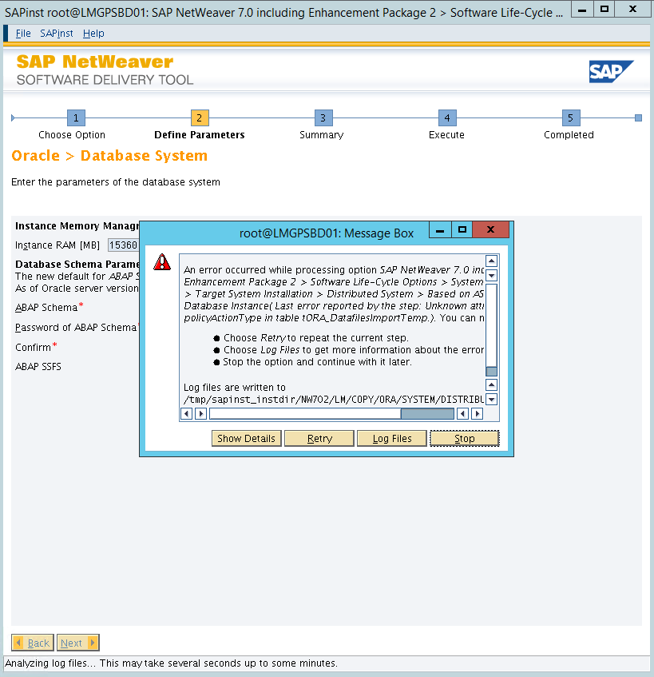

*make a backup from the file DBSIZE.XML in sapinst_instdir and \ABAP\DB\ORA then remove the columns*

*"policyActionType" and "policyDays" from the original one.*

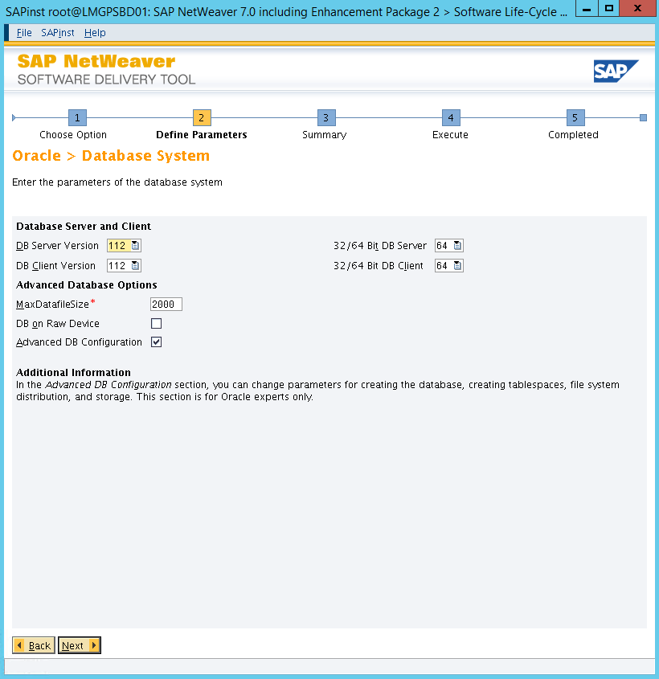

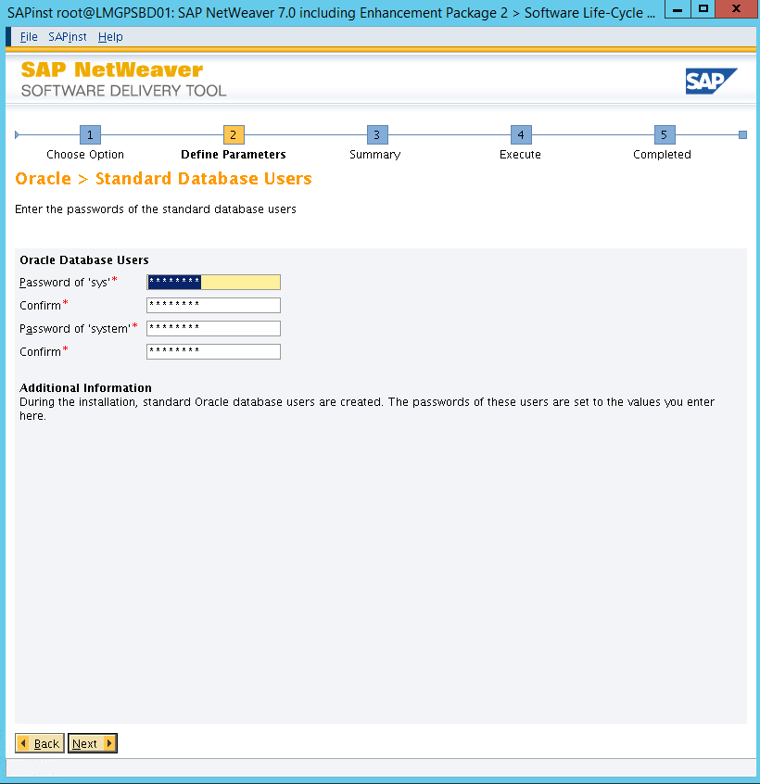

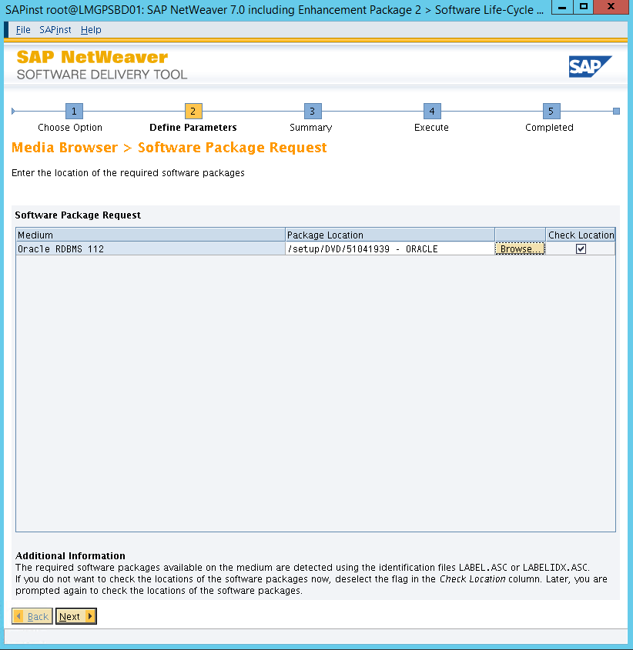

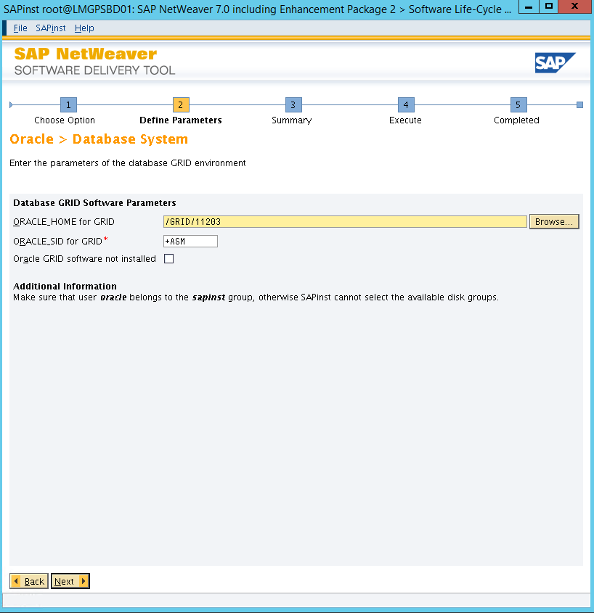

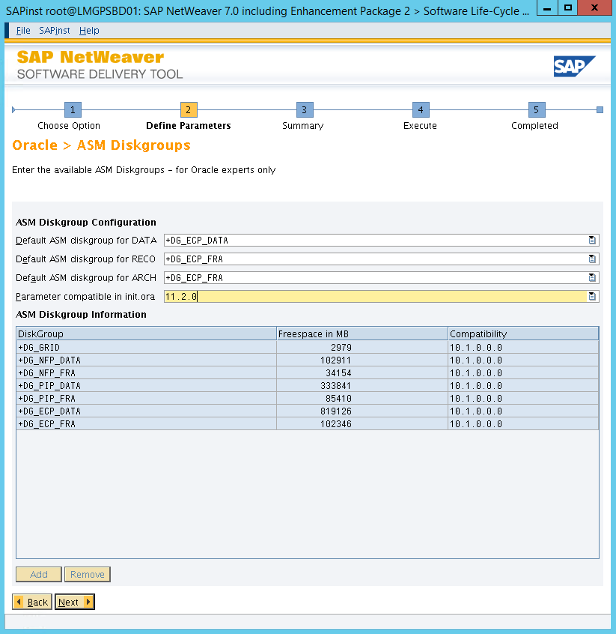

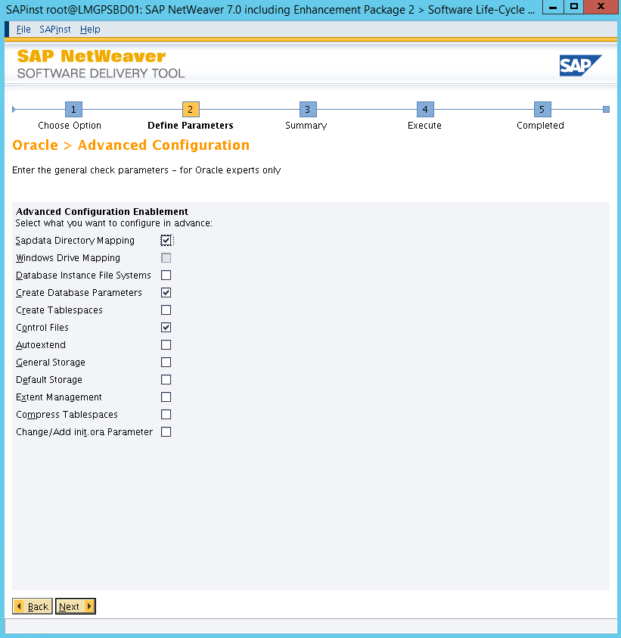

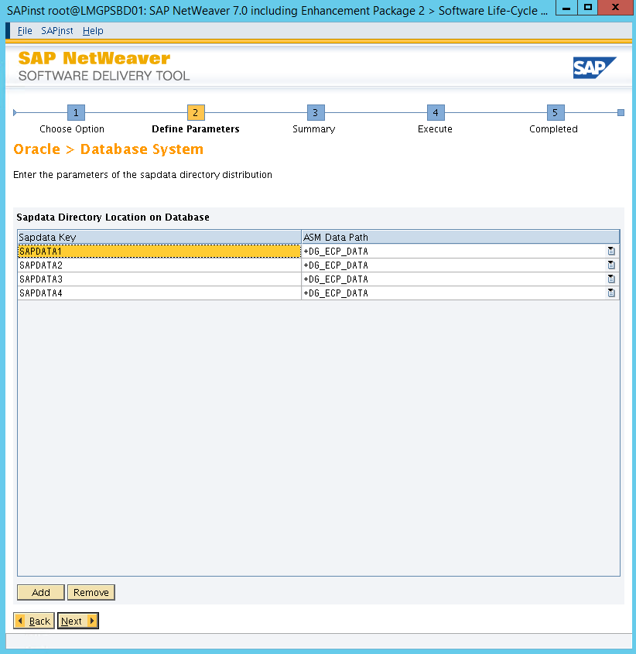

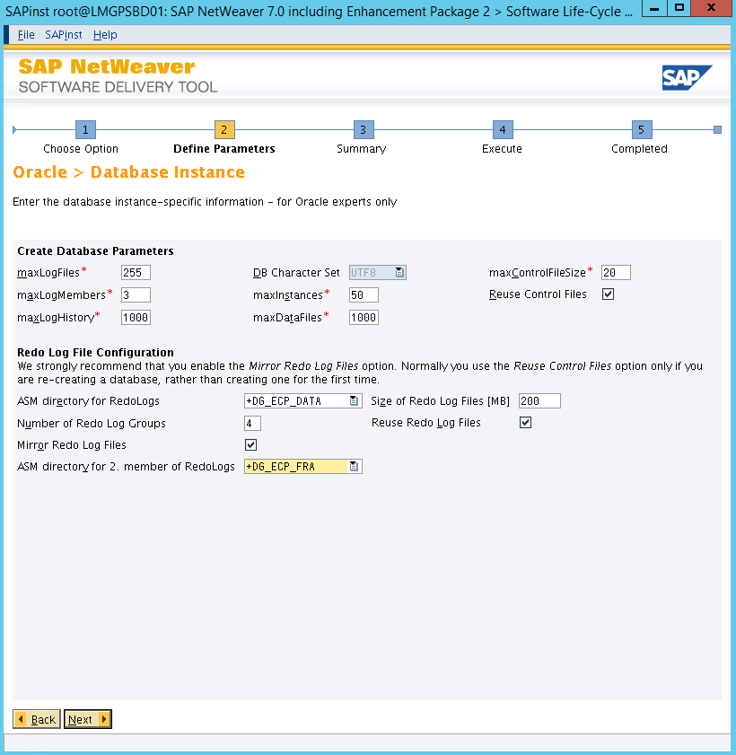

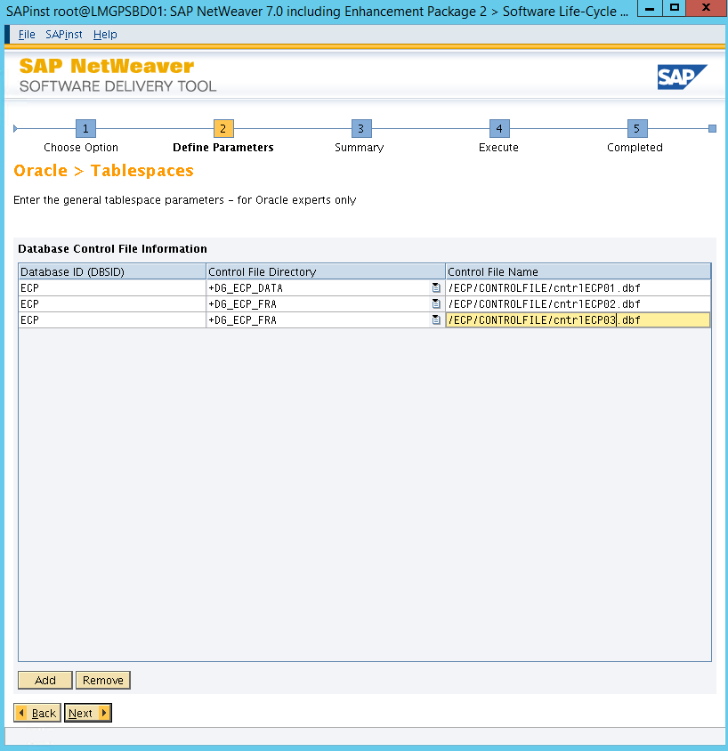

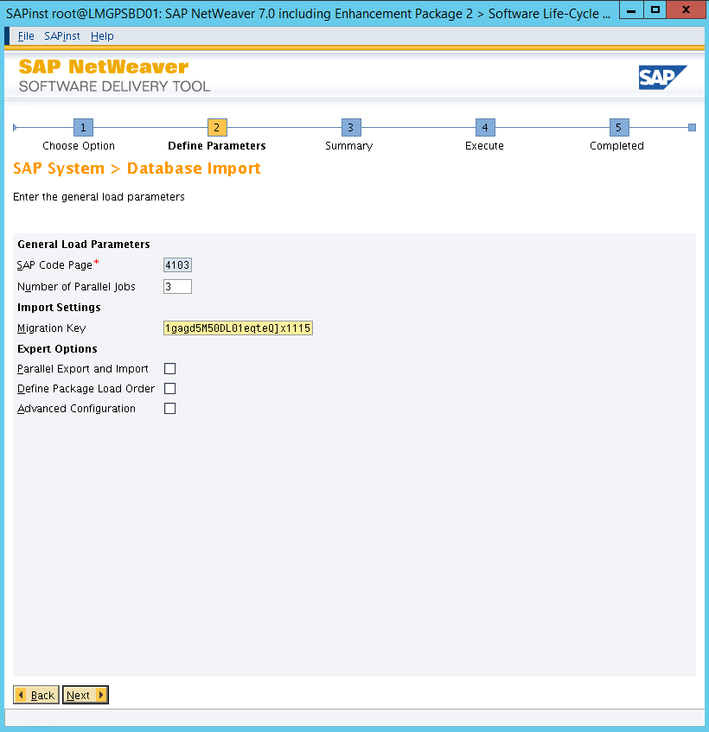

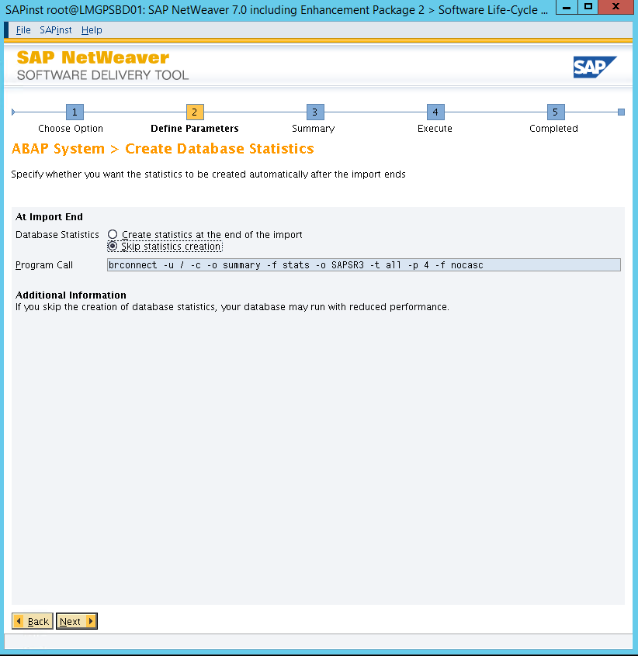

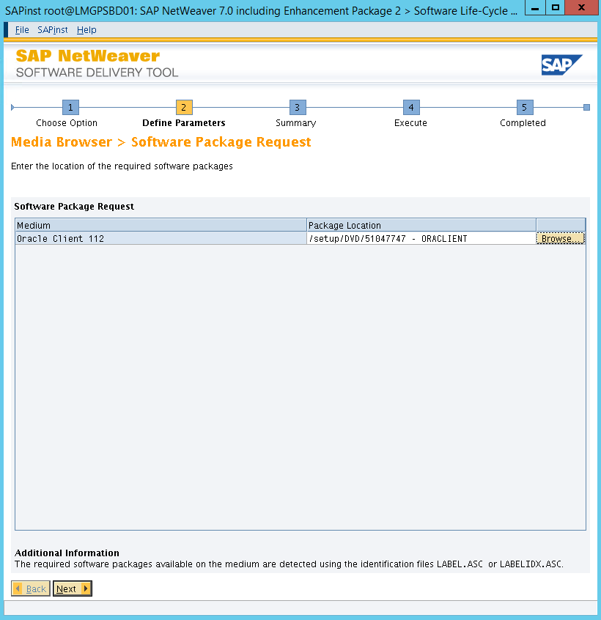

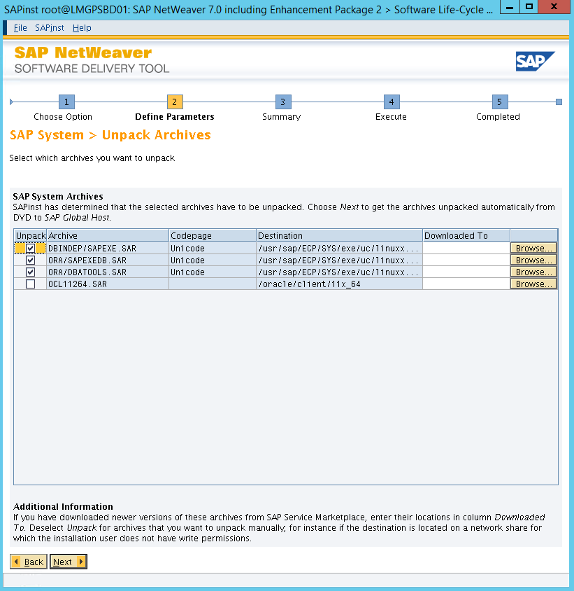

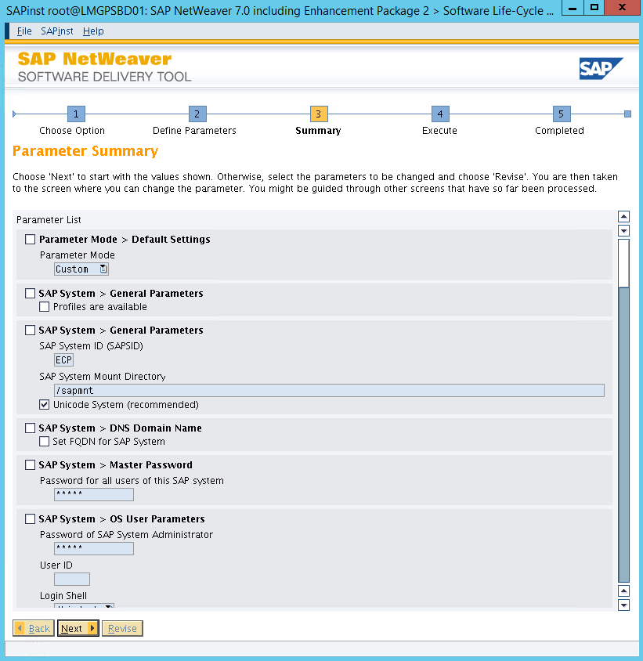

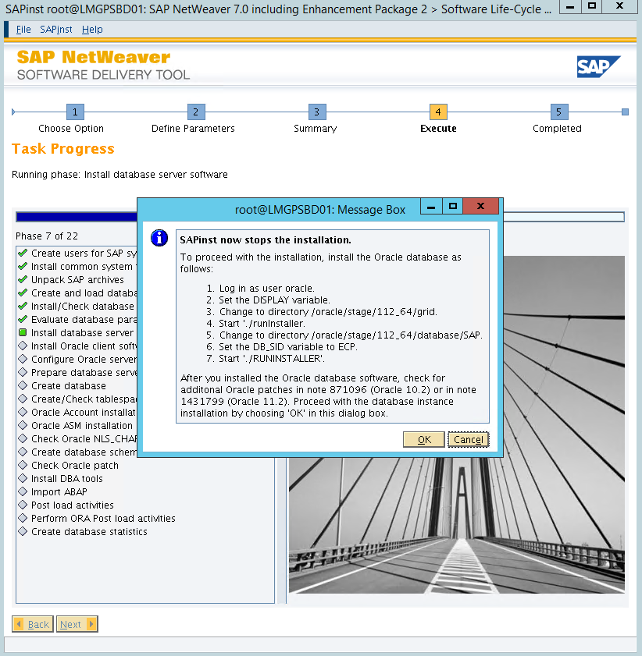





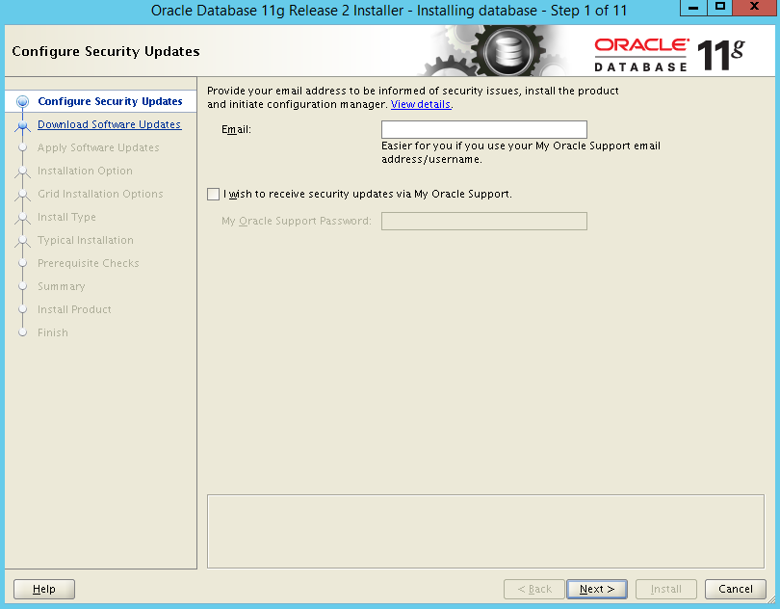

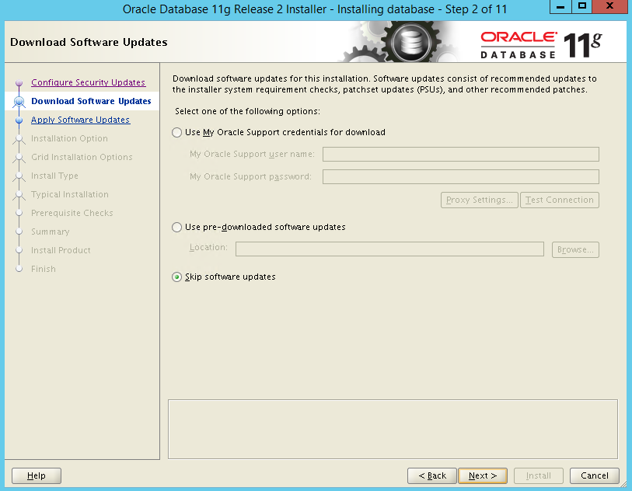

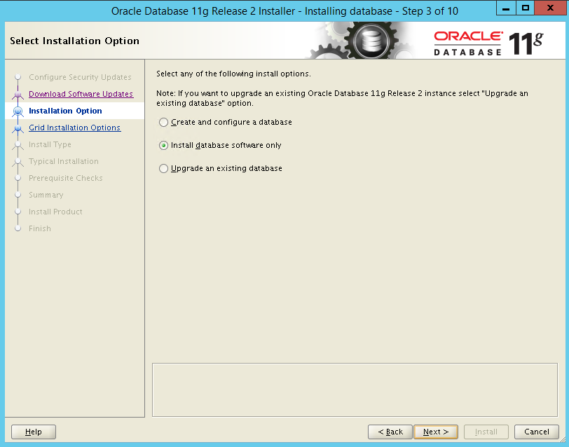

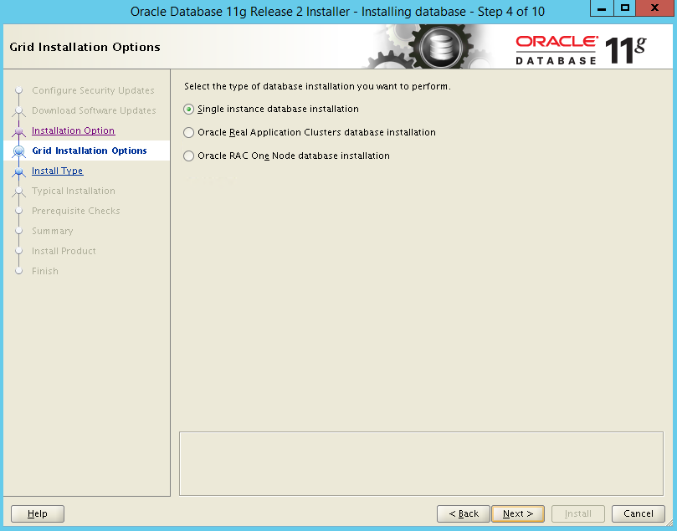

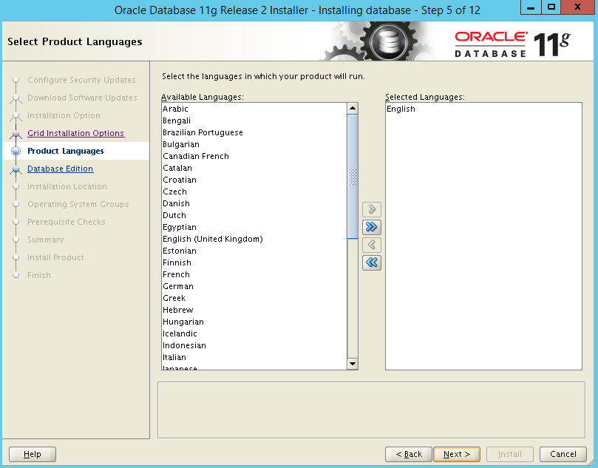

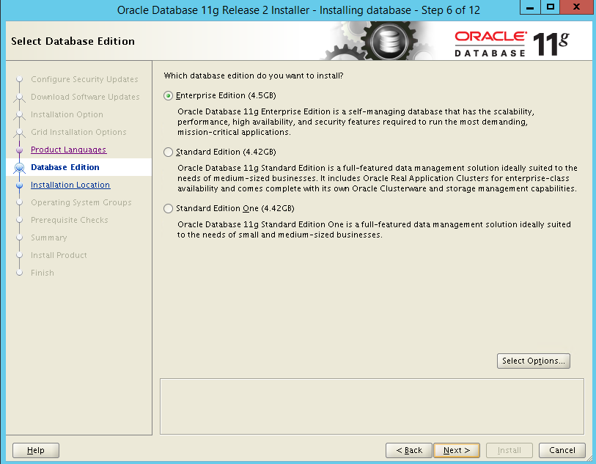

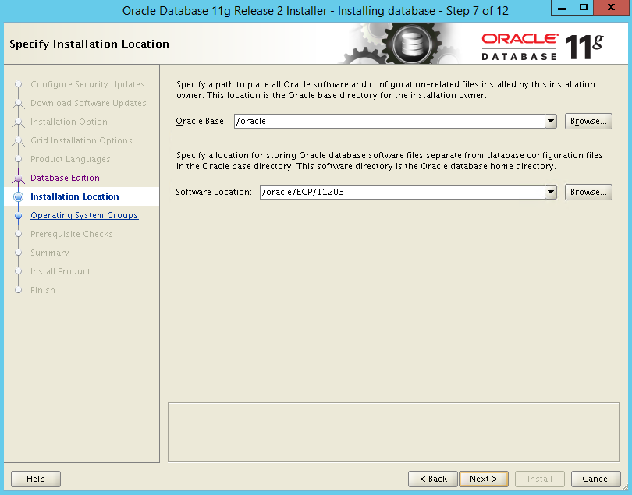

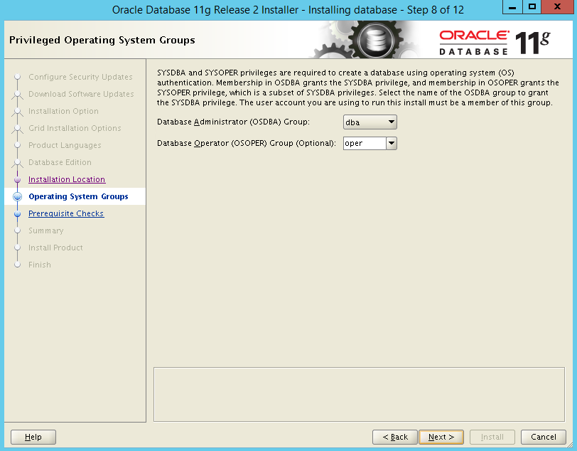

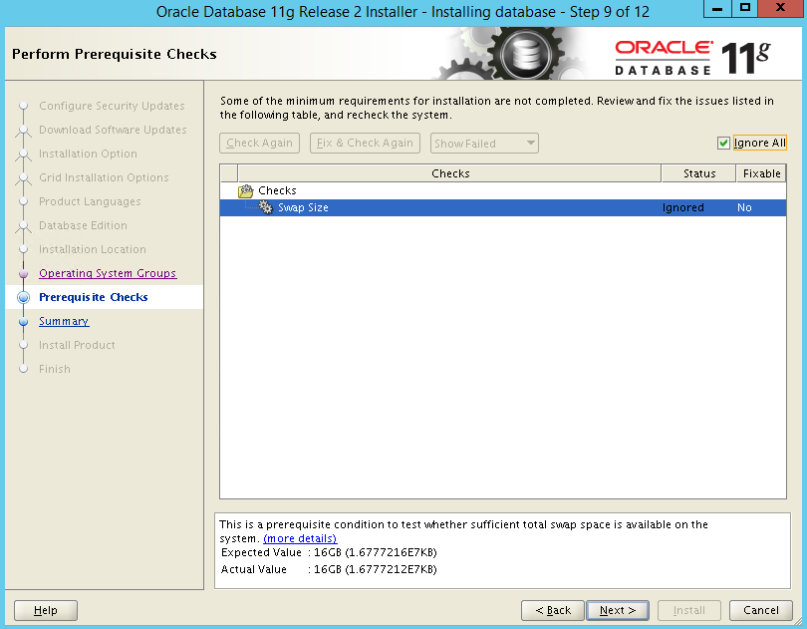

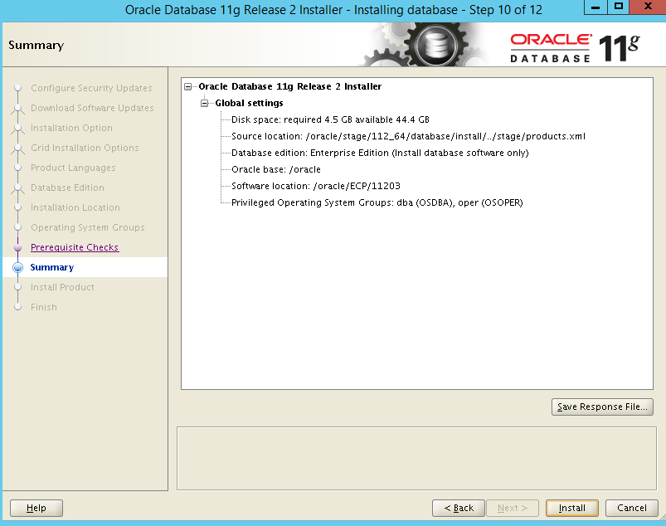

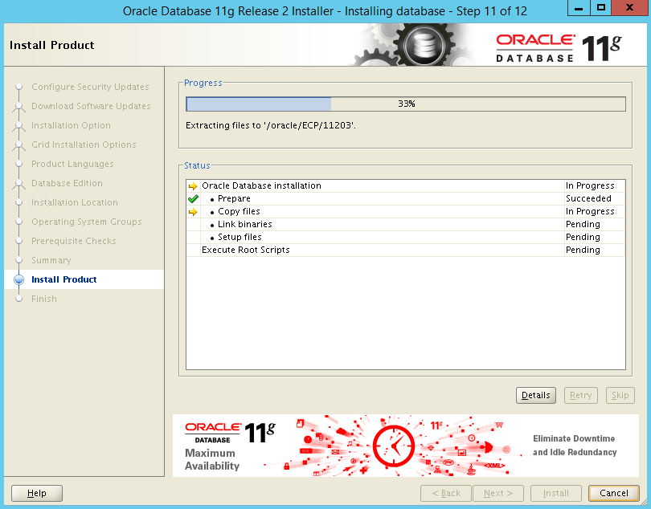

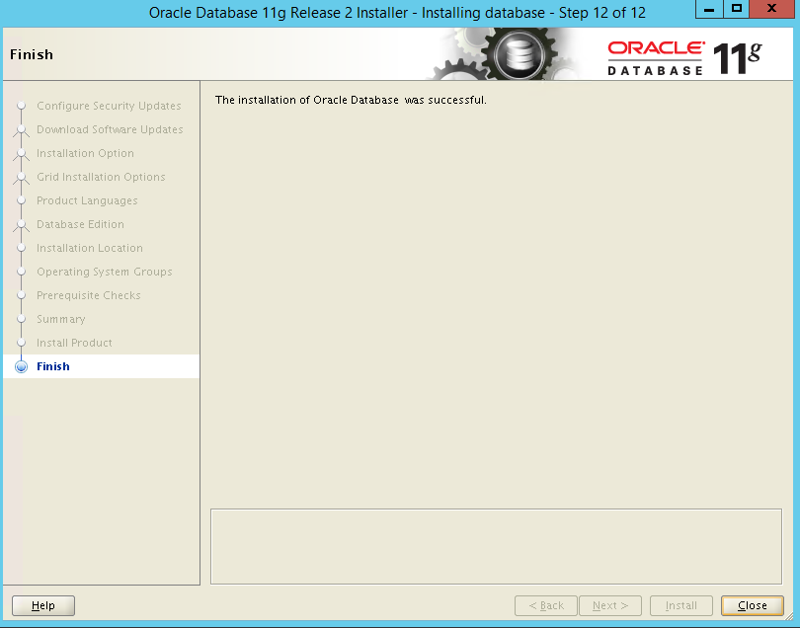

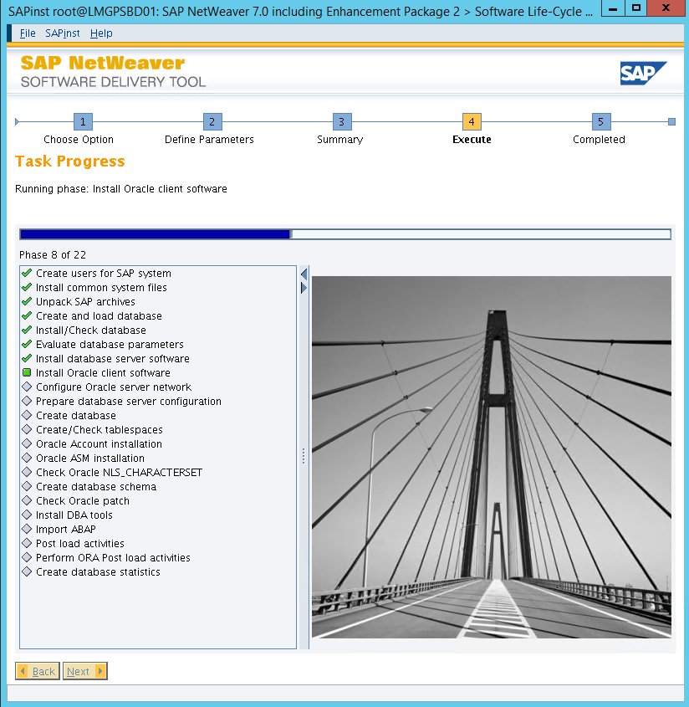

1. Ajustar TNSNAMES.ORA da instância primaria e standby
2. Copiar orapwd e verificar permissões
3. Gera controlfile do standby
   1. ALTER DATABASE CREATE STANDBY CONTROLFILE AS '/home/oracle/cntrlPIP01_STBY.dbf';
4. Alterar localização e nome dos controlfiles do standby e adicionar os parametros abaixo:
   1. #### DATA GUARD ###

*.cluster_database=false

*.db_unique_name='NFP_STBY'

*.fal_server='NFP1','NFP2'

*.log_archive_config='DG_CONFIG=(NFP,NFP_STBY)'

*.log_archive_dest_2='SERVICE=NFP NOAFFIRM ASYNC VALID_FOR=(ONLINE_LOGFILES,PRIMARY_ROLE) DB_UNIQUE_NAME=NFP'

*.log_archive_dest_state_2='ENABLE'

*.standby_file_management='AUTO'

*.fal_client='NFP_STBY'

*.db_file_name_convert='+DG_NFP_DATA/NFP/','+DG_NFP_DATA/NFP_STBY/','+DG_NFP_FRA/NFP/','+DG_NFP_FRA/NFP_STBY/'

*.log_file_name_convert='+DG_NFP_DATA/NFP/','+DG_NFP_DATA/NFP_STBY/','+DG_NFP_FRA/NFP/','+DG_NFP_FRA/NFP_STBY/'

*.thread=1

1. create spfile from pfile='/oracle/PIP/11203/dbs/initPIP_STBY.ora';
2. startup nomount;
3. rman target sys/pass@PIP auxiliary sys/pass@pip_stby catalog rman/pass@RMN
4. run

{

ALLOCATE auxiliary CHANNEL ch00 TYPE 'SBT_TAPE' PARMS'SBT_LIBRARY=/usr/openv/netbackup/bin/libobk.so64';

SEND 'NB_ORA_CLIENT=ldcrac02-bkp.intranet.local,NB_ORA_SID=NFP2,NB_ORA_SERV=wdcbkp01,NB_ORA_POLICY=Policy_DC_Oracle_PRD_NFP';

duplicate target database for standby nofilenamecheck dorecover;

release CHANNEL ch00;

}

1. Restaura os archives que estão faltando:

**rman target sys/pass@nfp_stby catalog rman/rman001@RMN**

run

{

ALLOCATE CHANNEL ch00 TYPE 'SBT_TAPE' PARMS 'SBT_LIBRARY=/usr/openv/netbackup/bin/libobk.so64';

SEND 'NB_ORA_CLIENT=ldcrac02-bkp.intranet.local,NB_ORA_SID=PIP2,NB_ORA_SERV=wdcbkp01,NB_ORA_POLICY=Policy_DC_Oracle_PRD_PIP';

restore archivelog FROM SEQUENCE 56019 UNTIL SEQUENCE 56140 thread 2;

release CHANNEL ch00;

}

1. Configurar os parâmetros no PRIMARY

ALTER DATABASE FORCE LOGGING;

ALTER SYSTEM SET LOG_ARCHIVE_CONFIG='DG_CONFIG=(PIP,PIP_STBY)' scope=both;

ALTER SYSTEM SET LOG_ARCHIVE_MAX_PROCESSES=30 scope=both;

ALTER SYSTEM SET LOG_ARCHIVE_DEST_2='SERVICE=PIP_STBY NOAFFIRM ASYNC VALID_FOR=(ONLINE_LOGFILES,PRIMARY_ROLE) DB_UNIQUE_NAME=PIP_STBY' scope=both;

ALTER SYSTEM SET LOG_ARCHIVE_DEST_STATE_2=ENABLE;

ALTER SYSTEM SET FAL_SERVER=PIP_STBY;

alter system set STANDBY_FILE_MANAGEMENT=auto;

1. Conferir se os archives foram aplicados no Standby (GAP)

select thread#, low_sequence#, high_sequence# from v$archive_gap;

e

select PROCESS,STATUS, THREAD#,SEQUENCE#, BLOCK#, BLOCKS

from v$managed_standby ;

e

*--Executa no PRIMARY e STANDBY pra conferir os ultimos arqhives aplicados*

SELECT thread#, Max(sequence#) "Last Standby Seq Applied" FROM v$archived_log WHERE applied = 'YES' GROUP BY thread#